Meeting of Muehl Public Library Board
Monday, January 2, 2024
5:46 PM

Members Present: Board President-Jason Finn, Library Director-Elizabeth Timmins, Darla Dorosz, Adam Schaumberg
Regrets: Sandy Heiden, Kristen Diermeier
Absent: Pat Krull, Lila Zastrow

Call to Order
Happy New Year!
List of holiday raffle winners was shared.
Word play joke was shared:
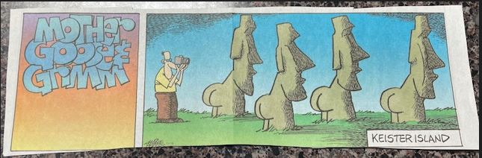

We did not have a quorum. ☹ We decided to run the meeting as best we could and do other business via email.
Jason called the meeting to order at 5:46.

Reports
- Minutes—November 6, 2023
- Director’s Report—Library Progress during November, 2023;
Library Progress during December, 2023
- Financial Report—December, 2023
- Activities Report—Complete through end of November, 2023

Jason asked if anyone had any feedback on the reports.
Darla, Adam and Jason approved the reports. We will need one more approval for the November minutes and one more approval for the December financial report. Thank you.

Unfinished Business
- LLD, February 6, 2024, can we please meet virtually on February 5, 2024?
  - Yes
- Annual Report, will be prepared for your approval at the Feb 5 board meeting
  - ET will work on this report during the month of January and run it by OWLS
- Website (Wordpress), launch, January 5, 2024!
  - Two meetings with Chad/OWLS were held in December. One in person and one on TEAMS for training.
  - ET now knows how to add an event and how to add a story in Wordpress.
- Parental rights handout (emailed separately)
  - This is a follow-up to the November meeting where we learned about proposed legislation in WI. This handout clearly delineates the ways in which parents can utilize Infosoup to keep track of library usage within families.
- Makerspace class—turned out to be four focus groups
  - Three groups were with patrons
  - High school seniors came to the library in December and ET did the presentation for them, also
  - ET needs to synthesize all of the ideas
  - The seniors gave particularly interesting feedback about video gaming and Wii

New Business
- Gift bequest and steps
  - The library has received a packet from Franklin Templeton on the passing of patron Richard “Pete” Mullen
  - ET made a phone call to ask questions
  - There is a complicated checklist that she was told to follow
  - She will be seeking advice from OWLS and will keep you posted
- 2024 goals for the director
  - ET listed her 2024 goals in the December director’s report
  - Darla reminded ET that she is hosting new school district staff on Monday, February 12, 2024 @ 3:25. Darla offered to help! Wonderful!
- Thank you to staff for inclusive attitude and executing Makerspace activities
  - This message was stressed and delivered to staff with their Christmas presents
- Highlight of staff talent on website
  - ET demonstrated the staff profiles on the site
  - Nifty the way the pictures flip and tell about the staff member
  - ET asked Chad to please add staff emails to the profiles
  - Darla complimented the format and content, thank you!
- Continuing Education: Message from Assistant Superintendent Underly (emailed separately)
  - ET emphasized the last line: “We believe in the freedom to read.”
  - Jason mentioned that we do not have an issue with that here meaning patrons do not complain

All board business was concluded at 6:12, the meeting adjourned.

The next meeting will be held Monday, February 5, 2023, 5:30 PM (This will be a VIRTUAL meeting, the day before Legislative Day.) Notes respectfully submitted by Elizabeth M. Timmins for Sandy Heiden.

