AGENDA FOR FMPL MONTHLY MEETING
THURSDAY, October 16, 2025, 6:30 p.m. to 7:30 p.m.

Timeclock Reminders:
Anime Afternoon: Sat October 25, 4 to midnight

Expansion fundraiser: Sat November 8, 1 to 5 at Seymour High School

Book sale: November 21 & 22; set up November 20 (sign up sheets will be on counter after October 25)

1. Call to Order & Reminder of Ground Rules:
A) Please raise hand to speak. B) Please speak to the topic at hand. C) PLEASE CHECK OUT (troubling trend)

*Thank you note from Cherry Buttles.

2. Additions or Changes to this agenda

3. Summary of Minutes of September 25, 2025 [any corrections?]

4. Treasurer’s Report – Submitted by Sherryl Pues
(*State of WI non-stock corporation annual report due 3.31 *By May 15, Form 990-N *State of WI raffle license—expires roundabout July 1; to be renewed by early August)

5. Committee, Activity and Events Reports
Chocolate Bars; Membership; Birthday Club; Papa Murphy’s cards; Bulbs’ sale one; Bulbs’ sale two

6. Old Business @ your library
- REACH OUT AND READ excursion
- Next QPR training @ the library

& 7. New business @ your library
- Push out the photo contest please.
- All about the EXPANSION FUNDRAISER…coming together amazingly
8. Wish list Performance rights’ license

9. Inspiration 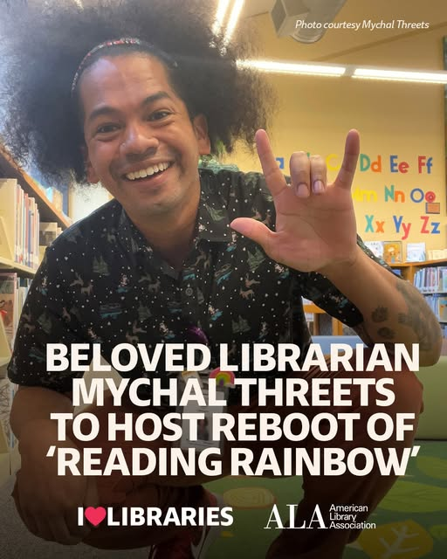

10. Adjournment
Next meeting…November 20 6:30, last meeting of 2025! Let the holiday season begin!

