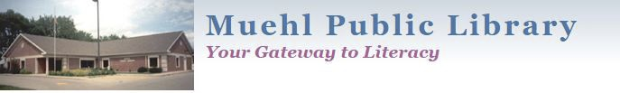

Visitor Pass Policy
Purpose
Our policy is that patrons can use the computers for two hours daily unless
they have special circumstances. Our library uses time out software on our
public computers. The stations are authenticated by patrons’ library cards.
When a person does not have a library card, a visitor pass can be printed
from the software (with a user ID and password) so that the person can
utilize a computer.
Policy
Visitor passes are given to patrons who are visiting from out of state or
from out of the country. They are also granted to patrons who do not have a library card. (All local patrons are encouraged to get a library card for
themselves.)
If a patron does not have their library card with them, and needs to go
online, they are granted one visitor pass. If that patron has fines we remind them about the fines. If a patron owes $5 or more on their library card, they are denied Internet access. The patron is not allowed to use the
Internet until the total owed on their card falls below $5.
Staff has the authorization to deny a visitor pass as deemed necessary.
Approved by Muehl Public Library Board of Trustees on January 6th, 2014. Reviewed and approved without revisions on June 7, 2021. Reviewed and approved without revisions on January 5, 2026.

