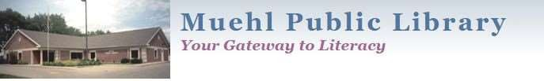
PPo
Po

Policy for Taking Photos and Videos of Patrons
Purpose
The Library frequently uses photos of patrons on its publications and display spaces to promote the value, and use of, library products and services. Taking photos of patrons is encouraged and puts the Library at no legal liability. The Library, less frequently, creates video content to engage the public and patrons. In both instances, some general guidelines should be followed to ensure positive patron relations.
Commercial Photography and Recording
The Library does not allow commercial photography or recording unless permission has been granted by the Director. Commercial is defined as used to promote and/or market products or services.
Organizations using the meeting space may photograph and video within the space.
Individual Photography and Recording
Permission is not needed for individuals to take photographs or videos inside the Library or of Library property where the public is permitted.
- Do not interfere with anyone’s enjoyment of the Library.
- Photos/recordings of minors and/or the use of their last name may only be used with permission of the respective parent or caregiver.
- If using oversized equipment, the permission of the Library Director must be obtained first.
- Be respectful of copyright. It is the responsibility of individuals to get permission from copyright holders before photographing or video recording any copyrighted materials.
Staff Photography and Recording
No permission is needed to take photos of crowds using the Library or attending programs. Anyone who does not wish to be photographed or recorded should inform a staff member.
(This policy also extends to any FMPL events.)
Cessation
The library reserves the right to ask any individual to discontinue taking photos or videos.

The origin of this policy (photos) was created in 2009, with permission, from the Washington-Centerville Library in Centerville, OH. The author is Georgia Mergler, Community Relations Manager, for that library.
New content (video) was inserted with ideas from the Jefferson County Public Library, WI.
This policy was approved by the Muehl Public Library Board of Trustees on May 4, 2026.

